Name: Myles Sartor
Inputting and Editing DATA (MOL2)
- Choosing a Default Working Directory:
  - Download all the files for this Assignment into a folder on your computer you will create. Give it a name and choose this folder as your Default Working Directory. Putting all the files you will use in R into one folder will make it easy to save and find your data files.
  - Once you have created/chosen a file, then go into R Studio and choose it as your Default Working Directory as seen in the PowerPoint (or any method that you may have already learned – there are several ways to create a Default Working Directory in R Studio).
  - Close R Studio.
  - Open R Studio, and in the lower right pane, select Files and take a screen shot of the directory you have chosen. Copy and paste this screen shot here (1 pt):
Results: 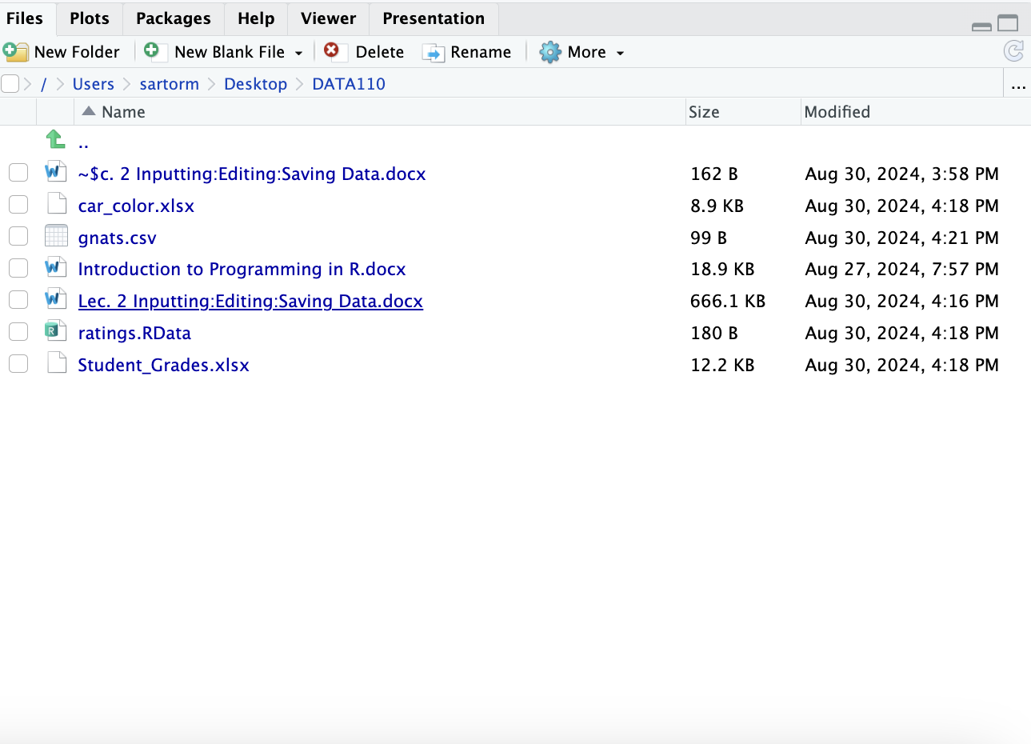

- Input the following DATA as a vector:
  - Name the following DATA num1 and input as a vector in R Studio: (11,13,15,20,22,23,25)
  - Name the following DATA num2 and input as a vector in R Studio: (22,24,27,19,16,31,21)
  - Name the following DATA num3 and input as a vector in R Studio: (77,66,55,44,33,22,11)
  - View all three DATA sets.
  - Copy and paste your commands and results in R Studio Console here (2pt):
Results: 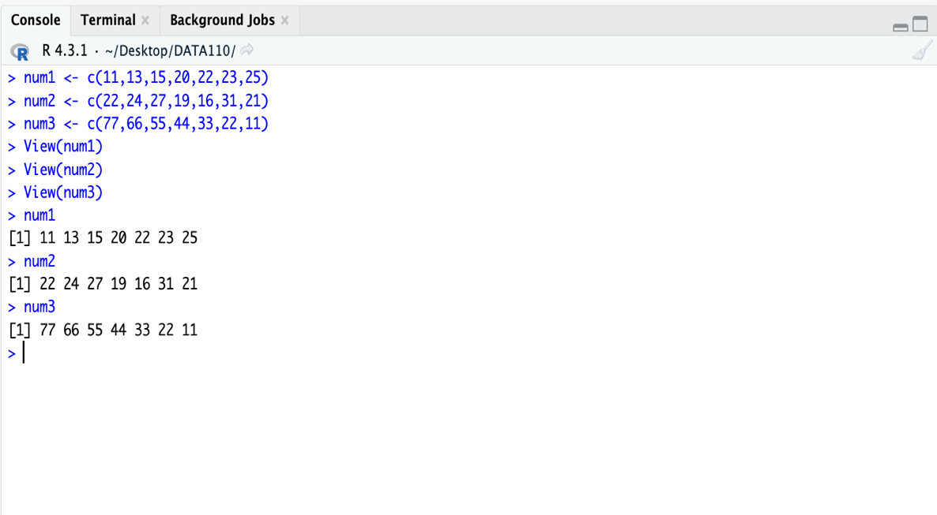
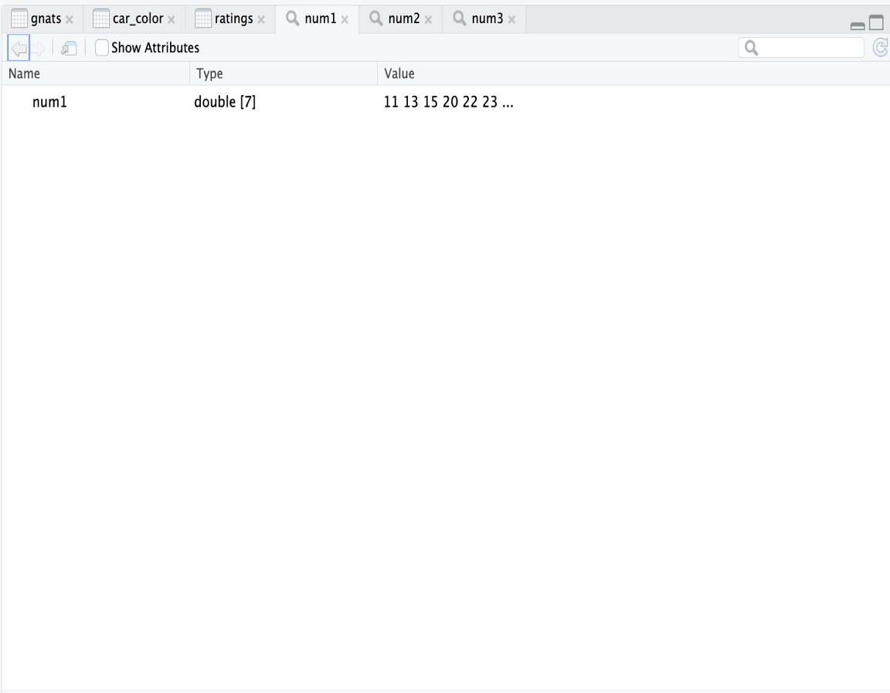

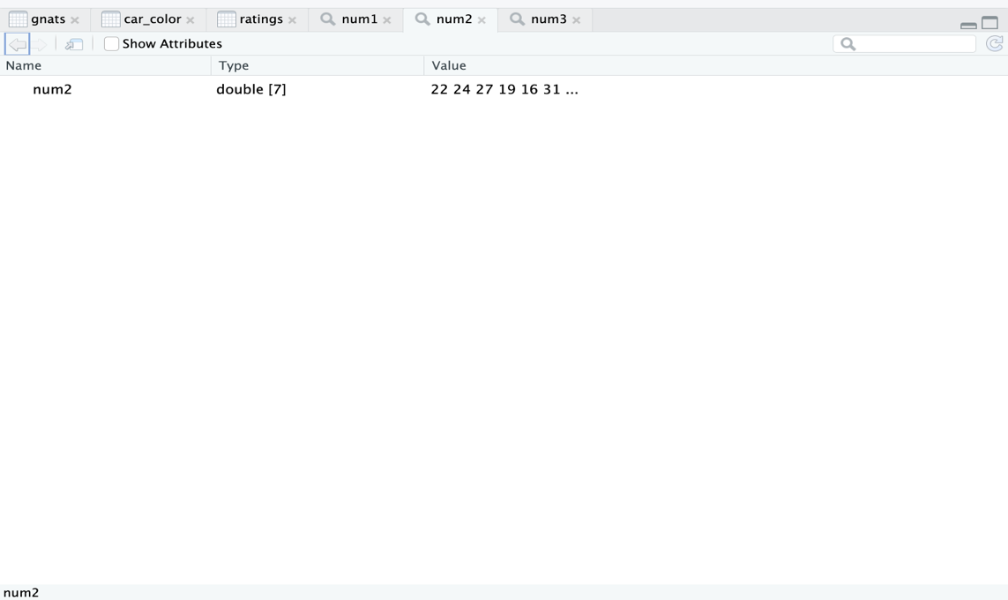
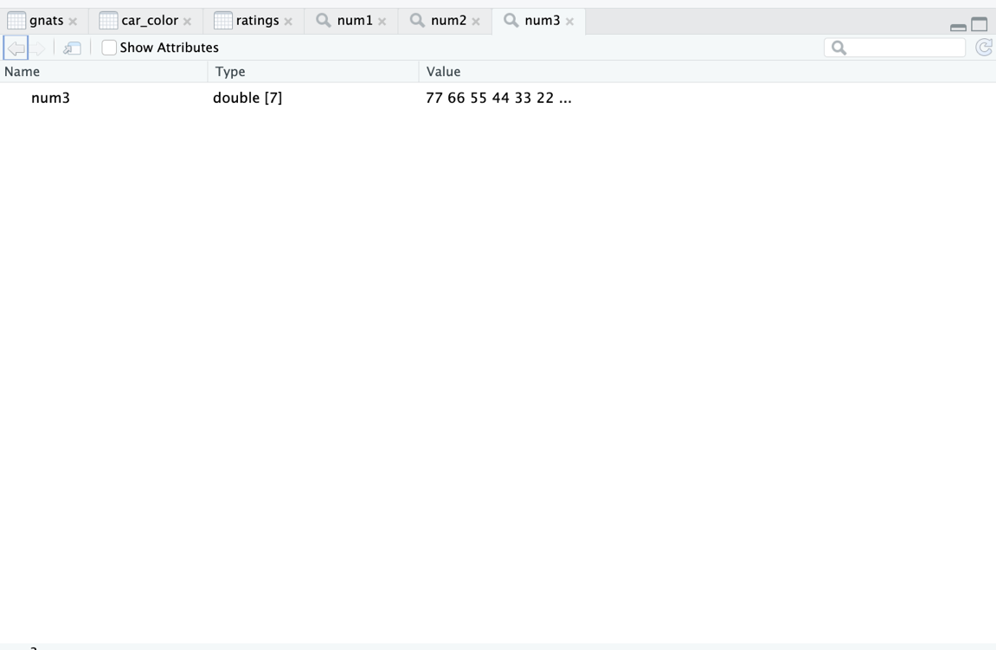
3 uses of view command as well
- Input the following CSV file into R that has the variable name in first row (heading): gnats.csv
Take a screen shot of the Global Environment and console in R (1 pt):
Results: 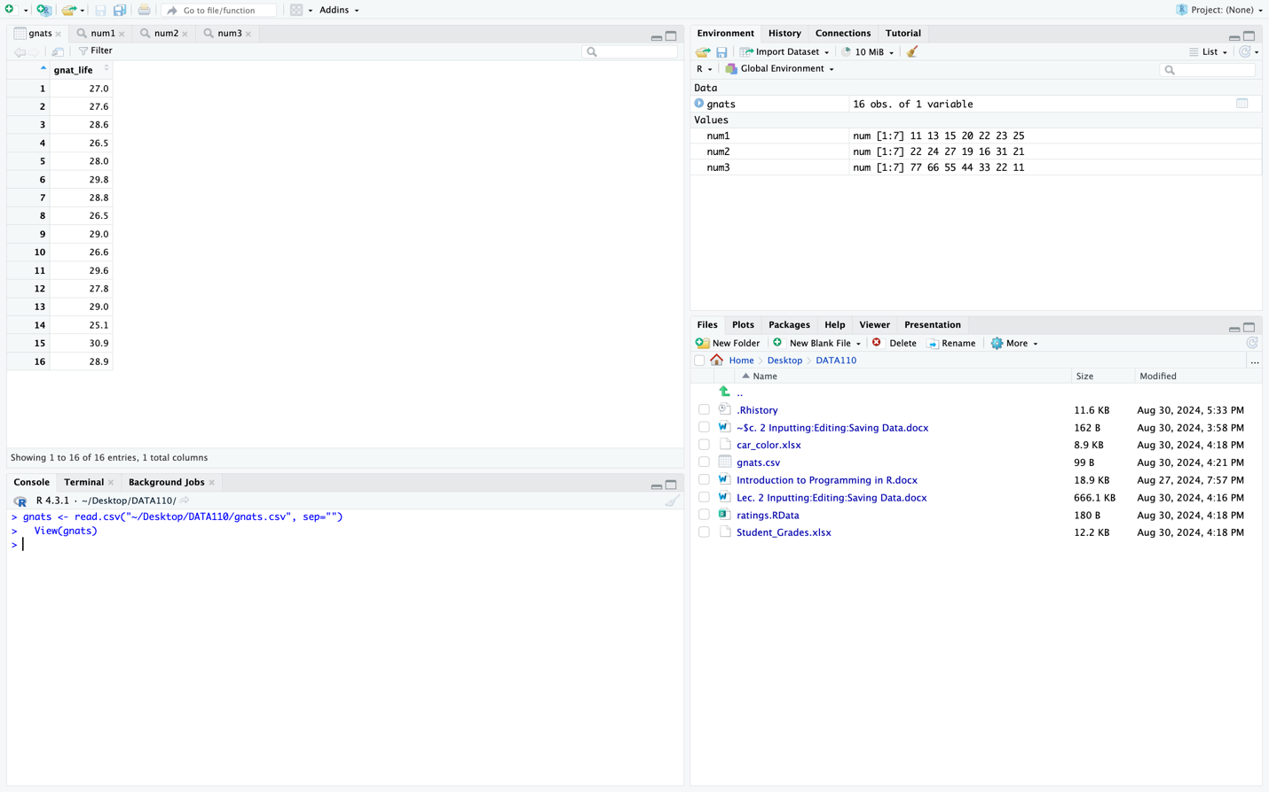

- Input the following .xlsx file into R that has the variable name in first row (heading): car_color.xlsx
Take a screen shot of the Global Environment and console in R (1 pt):
Results: 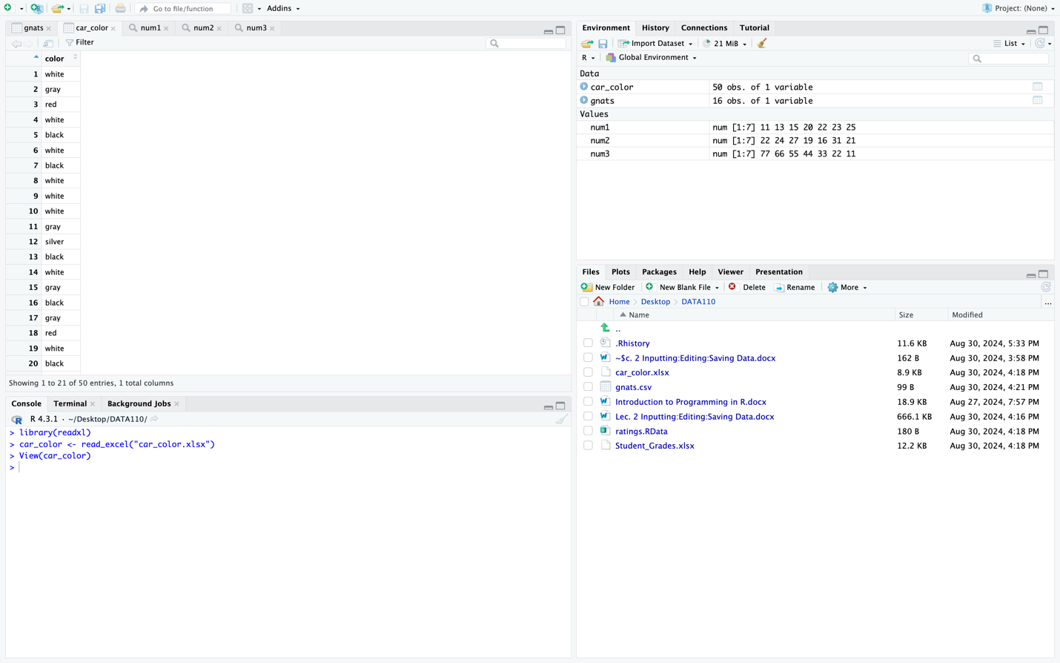

- Input the following .RData file into R that has the variable name in first row (heading) then use View to view file: ratings.RData
Take a screen shot of the Global Environment and console in R (1 pt):
Results: 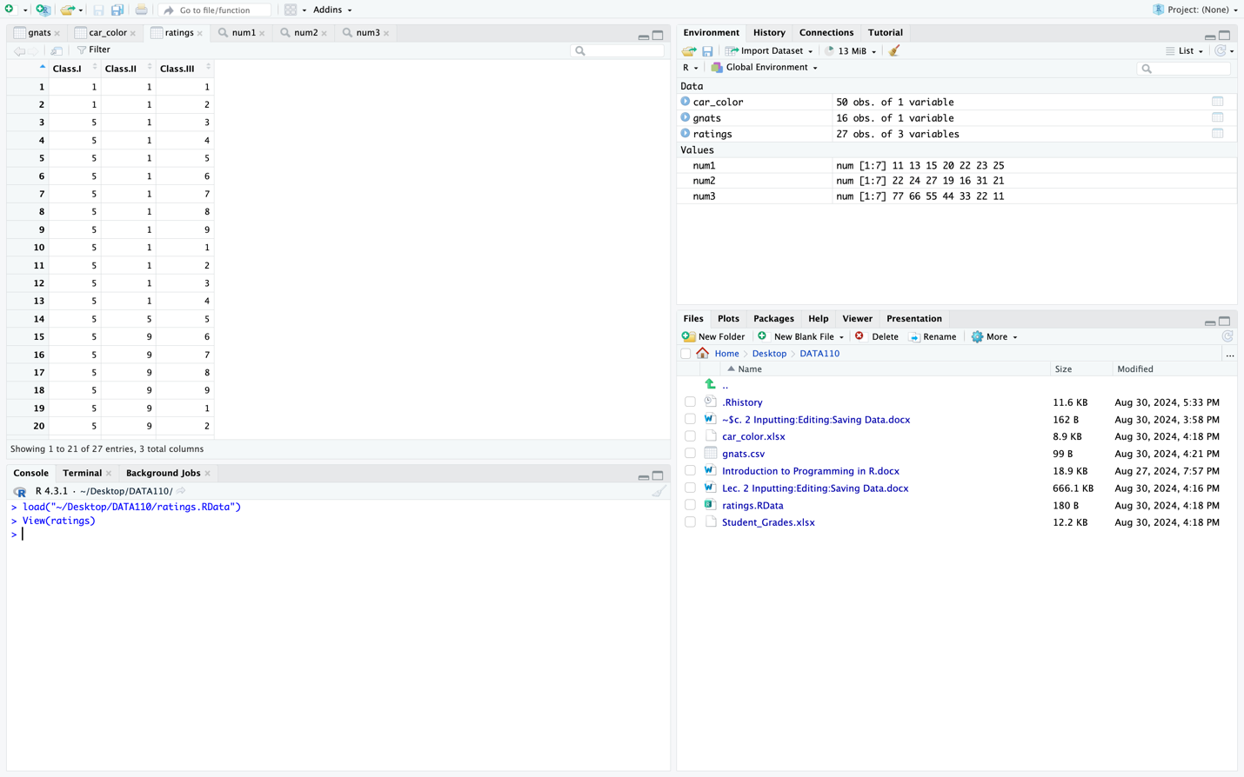

- Simulate a sample of 100 from a Normal Distribution for the height of an oak tree with a mean of 60 feet and a standard deviation of 20.2 ft. Give the name of the column vector Height_of_Oak.
Take a screen shot of the Global Environment and console in R (1 pt):
Results: 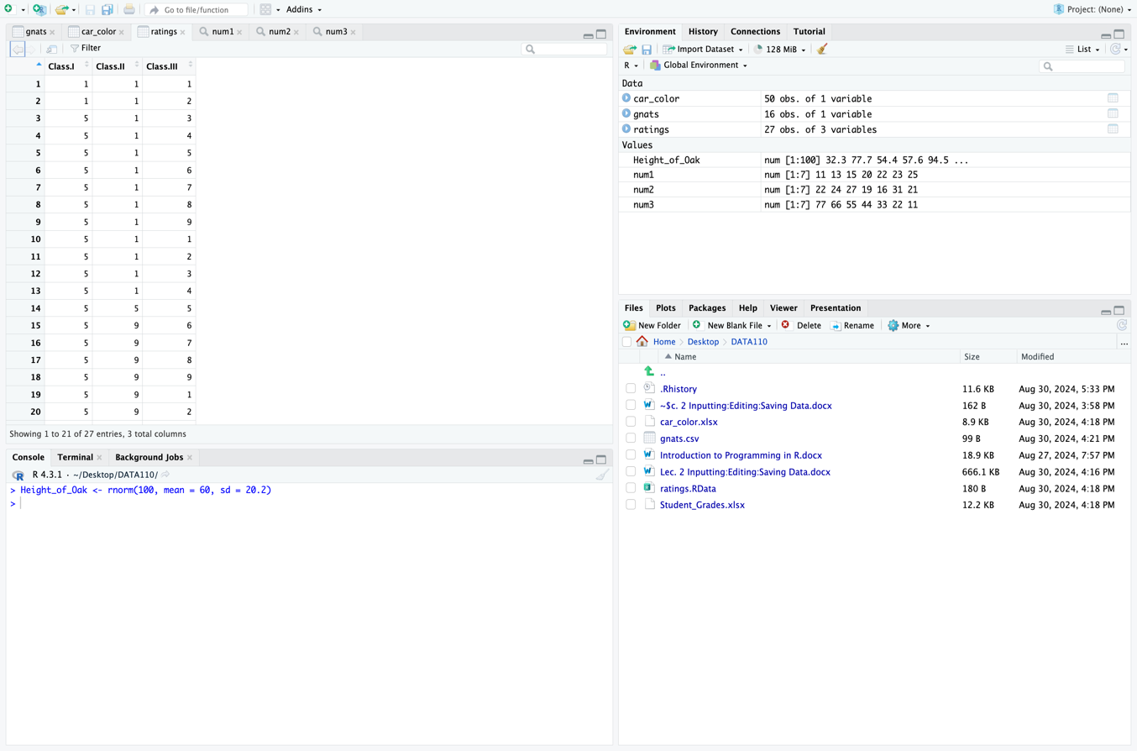
(Console and global environment in picture)
- Create a random sample of 4 without replacement from the following DATA num1 you created earlier, call the column vector, sample_of_4. Then type sample_of_4 to view the column vector
Take a screen shot of the Global Environment and console in R (1 pt):
Results:
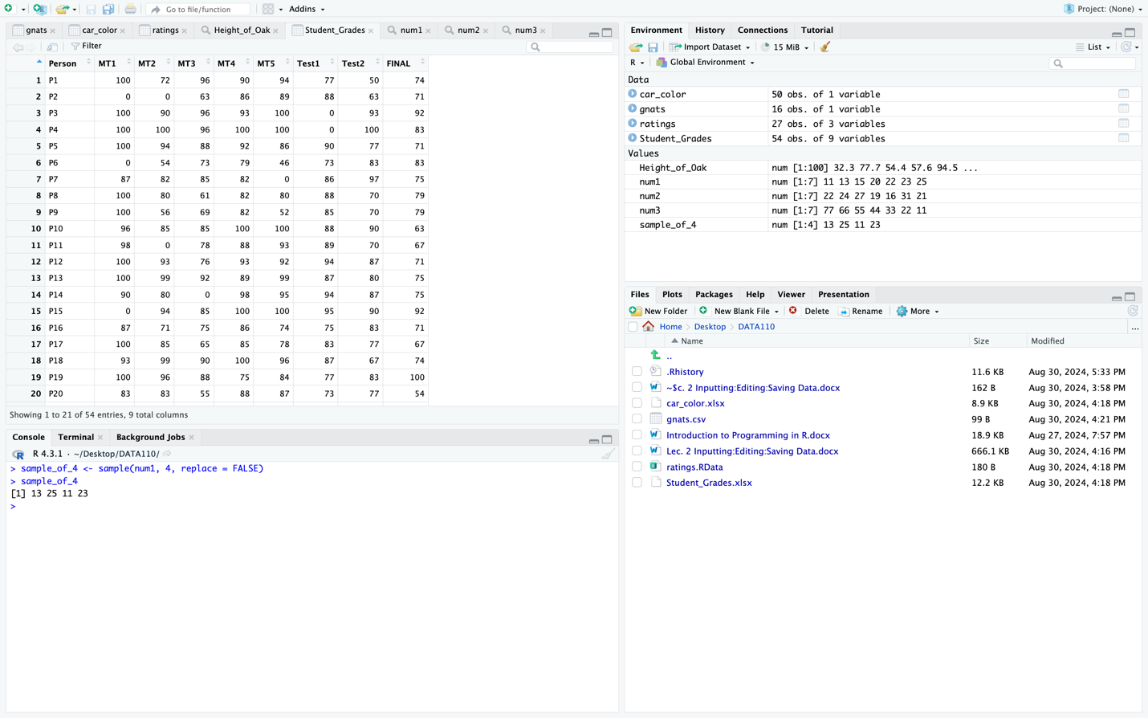
(Console and global environment in picture)
- Upload the data set Student_Grades.xlxs , then edit the file in the following ways:

  - Create a new file called MT_Grades.csv from the Student_Grade.xlxs file where you will select only the Person, MT1, MT2, MT3, MT4 and MT5 Grades, calling the subset file temp_MT
Save the file as a csv file called MT_Grades.
You will see the new file, MT_Grades.csv in the working directory. Import that file (Click on temp_MT.csv , select Import Dataset)
Make sure you have the file tab open in the bottom right of R Studio.
Take a Screen shot (1 pts):
Results:
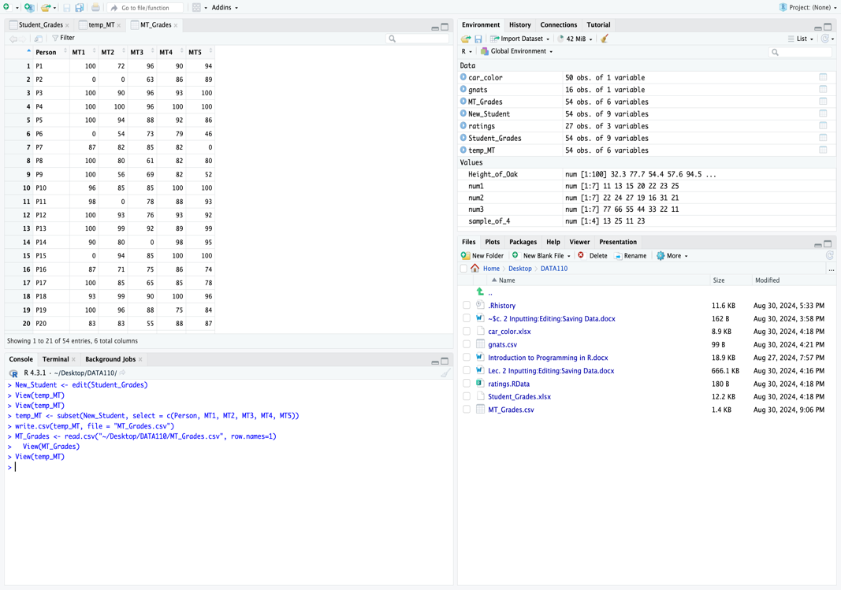

  - Create a new file called Exam_Grades.csv from the Student_Grade.xlsx file where you will delete MT1, MT2, MT3, MT4 and MT5 Grades, calling the subset file temp_Exam
Save the file.
Then View the new file, Exam_Grades.csv, following the directions in part a.
Take a Screen shot (1pts):
Results:
